AutoSAP ABAP EWA Dumps Monitoring
Solution Manager signatures signify that approvers have read, understood, and agrees with the content of this document.
Name | Job Title and Role
Akoju Sharanya | The author is signing to confirm that this document has been prepared in accordance with an approved document management process, that content is consistent with the deliverable definition found in Specify System, that relevant input from any contributory authors has been included and that an appropriate review / editing process has been conducted.
Akoju Sharanya | The Developer (selected by the Project Manager as responsible for the design of the system) is signing to confirm that the Design Specification is fit for purpose, that it will deliver a computer system that satisfies the System Requirements and that it will be used for the development or configuration of the computer system

Table of Contents
1 Introduction 3
2 Definition/Acronyms 3
3 General Statement of Design 3
3.1 Assumptions 3
4 References 3
5 Platform Architecture and Environment 3
6 Software Architecture 4
6.1 Generic Solution Details 4
7 System Operation Specification 7
8 Data 7
9 Security 7
10 Revision History 7
11 Appendices 7

Introduction
ABAP team monitors the EWA Dumps which are getting generated through st22 T-Code. This document describes the Automated process of counting the no. of dumps getting generated in different systems RAP, RBP,RWP,LMP,SLP,MGP.

Definition/Acronyms
Item | Definition
SAP | Systems Applications and Products
SID | System ID

General Statement of Design
Design methodology/principles | This task is developed to overcome the manual effort and time spent on routine activity. The scripts are developed for end-end execution of notifying the dumps count of different systems  Script will login to each Prod system and executes ‘st22’ T-Code to get the Dumps list. Script will then take the screenshots of dumps for evidences and counts the no. of dumps which will be indicated in the excel format and at the end script sends an email to the ABAP team attaching all the evidence
Tools + version | Python 3.10.11, Pandas, SAP GUI 760, SMTP mail.
Programming standards | GSK Programming Standards.

Assumptions
Assuming the t-codes st22 T-code is working fine .

References
None

Platform Architecture and Environment
Python 3.10.11

Software Architecture
Element ID | Developed Software Unit name | ID | Programming Language(s) | Description of Purpose
DS/ABAP_SAP-CC/0001 | Program | AutoSAP EWA dumps.py | Python | This is the main file which imports remaining files to perform the SAP actions
DS/ABAP_SAP-CC/0002 | Program | cc.py | Python | This is the file where credentials are read.
DS/ABAP_SAP-CC/0003 | Program | St22.py | Python | Perform the dumps count.
DS/ABAP_SAP-CC/0004 | Program | sender.py | Python | Sends the report and summary of dumps to the ABAP Team.
DS/ABAP_SAP-CC/0005 | Program | logon.py | Python | This file logs into the SAP

Generic Solution Details
Authorisations
No Authorisations checks implemented as Authorisations are derived from user.
Message Class and Messages:
NA
Manual Process:
SYSTEM: RAP, RBP, RWP, LMP, SLP, MGP

T-Code: st22

Step1: login to RBP system enter the T-Code ‘st22’
No click on Goto Overview
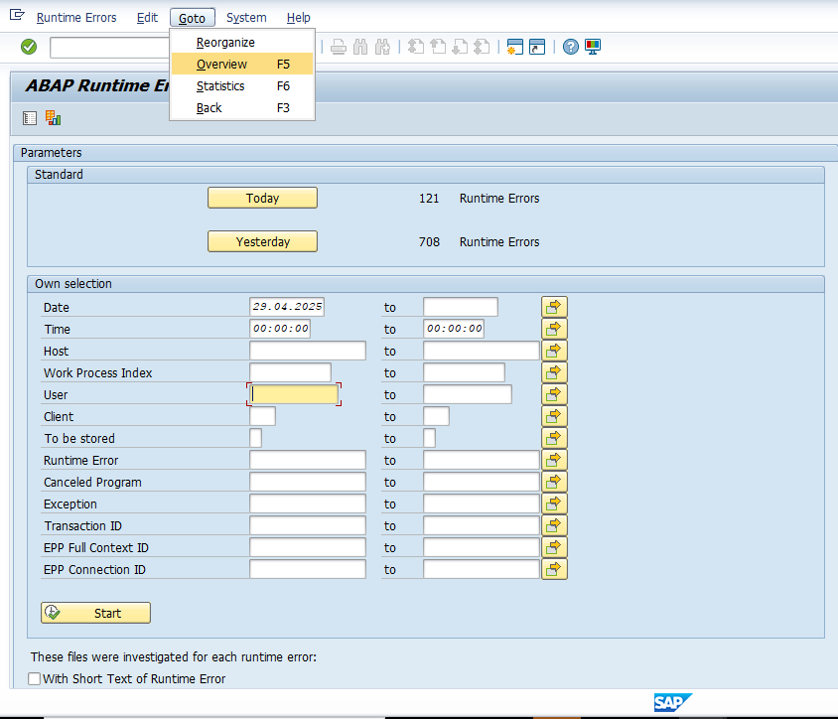

Step2: Give the date as yesterday’s date and click on execute button.
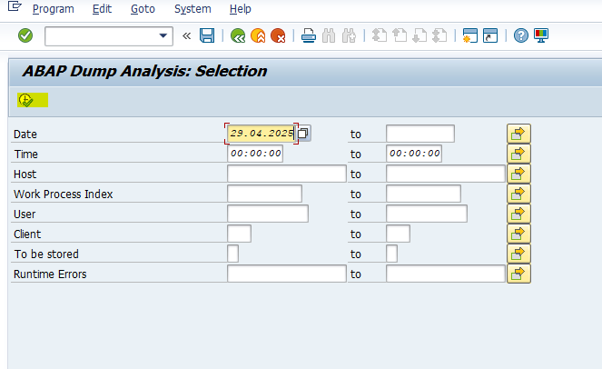

Step3: you will get the dumps displayed
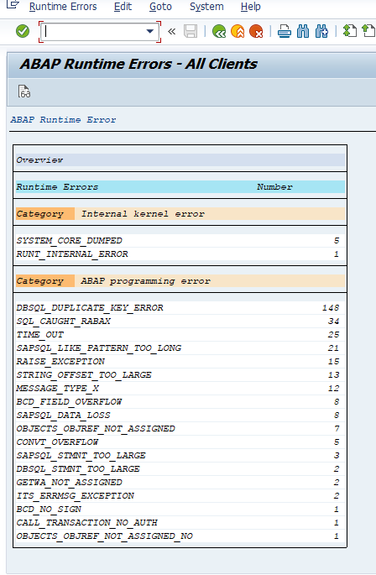

Step4: The above steps are repeated for all other Prod systems.

Input Format
NA
Output Format
NA
Output Medium
Print
Screen Summary
NA
Business Logic:
For detailed specification of the development please refer to Appendix – Program Logic
Run Mode
Foreground
Error Handling
We are handling one error case here,
- No short dumps matches the selection criteria: It is the scenario where no job matches the selection criteria and no spool list exist. In this case the count of dumps is considered as ‘Zero’
- 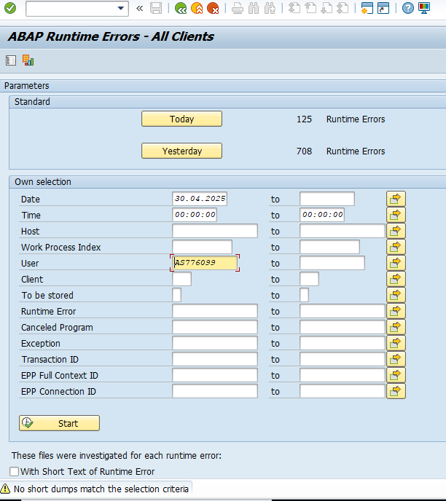

System Operation Specification
NA

Data
NA

Security
NA

Revision History
Version | Source |  | Reason For Revision
Version | Deployment | BAU | Reason For Revision
1.0 | Apr-2025. | NA | This is the first issue of the document and initial version created for AutoSAP_001.

Appendices

Appendix – Selection Screen Definitions
NA
Appendix – Screen Layout Definition
NA

Appendix – Program Logic
Element ID | Logic Description
Autosap_ABAP_EWADumps | • Script will log into each SAP system (RAP, RBP, RWP, LMP, SLP, MGP) and execute the ST22 transaction code to fetch the dumps generated for yesterday’s date.  • After retrieving the data, the code counts the number of dumps generated and updates this in a generated Excel file.  • Screenshots of the dumps for all systems are taken as evidence.  • These steps are repeated for all the remaining systems.  • At the end, an email is sent with the summary report attached.

Appendix – Output Layout Details
NA

Appendix – Sample Output Formats
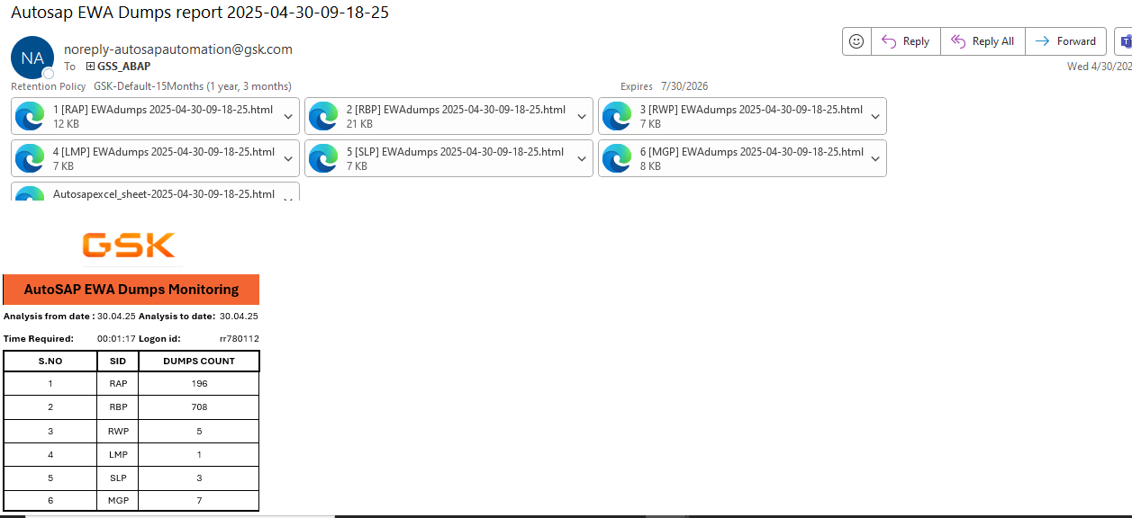

Appendix – Function Module Detail
NA
Appendix – Further Solution-specific sections
NA
Appendix – IDOC Detail
NA
Appendix – Data Dictionary Objects
NA
Appendix – Portal / Java Developments
NA
Appendix – Data
NA

